Can•Innovate
Activity Guide
for Group Viewing Rooms
brought to you by the CVC-OEI/@ONE
Friday, October 25, 2019
9:00 am - 5:00 pm

Get session resources here:
OnlineNetworkofEducators.org/CanInnovate19
Share your takeaways and photos on Twitter with #CanInnovate19

Table of Contents
Can•Innovate 2019
Integrating Compassion into Your Teaching
Applying the Peralta Equity Rubric to Promote Connection and Belonging
Meet the CCC Canvas Community Home Base!
Javascript Magic in Canvas: Randomizing Widgets, No Coding Required!
Beyond Canvas: The CVC Exchange and Local POCR
Audio Feedback! Instructor Interactions that Motivate Students
ConferZoom for Dynamic Student Conferences
12 Noon Lunch Break - Canvas Trivia with Kahoot!
Quick Fixes using Tools to Create Accessible Content
Group Discussions for Increasing Interaction, Engagement, and Equity
Data at Your Fingertips: Supporting the Success of all Learners
Using Flashcards for Self-Assessment
Embedding Quizzes in Video
Design 2 Align Camp: A Model for Redesigning Courses in Community
Taking the Pain Out of “Group Work”
Stump the Panda
Bringing the CVC-OEI Online Ecosystem to Life through the MiraCosta College Student Support Hub

Can•Innovate 2019

Integrating Compassion into Your Teaching
Kona Jones, Director, Online Learning, Richland Community College
Points to Ponder
● Who are your students?
● How can you facilitate their success?
● What interventions would you like to try?
● Small changes you might make?
● How will you know your changes make a difference?
You may use the area below to draw, sketch, or describe your current student(s) and what your goals will be for your student(s) after you have implemented some ideas from this session.
Current Students

Goals for Students

Applying the Peralta Equity Rubric to Promote Connection and Belonging
Chelsea Cohen and Inger Stark, Laney College, Peralta Community College District
Peralta’s webpage on the rubric now has the most recent version (May 2019) and two other docs, one that explains each criterion, and another that gives an overview of the research used in the rubric design. (https://web.peralta.edu/de/peralta-online-equity-initiative/equity/)
Keywords:
• Technology Resources • Student Support Services • Universal Design • Images • Bias •
• Diverse Perspectives • Connection • Relevance • Belonging • Expression • Engagement •
How could the Equity Rubric be applied at your college?

Meet the CCC Canvas Community Home Base!
Logan Murray and Mike Vogt, California Virtual Campus-Online Education Initiative (CVC-OEI)
Complete a few of these items to connect with your CCC colleagues in the CCC Canvas Home Base:
❐ Create a personal Canvas Community profile
❐ Join the CCC Home Base Group
❐ Look at a discussion (feel free to respond)
❐ Identify a topic you are you are most interested in learning more about.
❐ “Follow” a CCC colleague from another college
❐ People: Who do you know or recognize?

10-10:45 Canvas Combo Session 2

JavaScript Magic in Canvas: Randomizing Widgets, No Coding Required!
Laura Gibbs, University of Oklahoma
Widgets.mythfolklore.net
- A widget you want to try:
- What does the widget do?
- How a widget might inspire and motivate your students:
- Which one of your courses could use some widget magic?

Beyond Canvas: The CVC Exchange and Local POCR
Jory Hadsell, California Virtual Campus-Online Education Initiative (CVC-OEI)
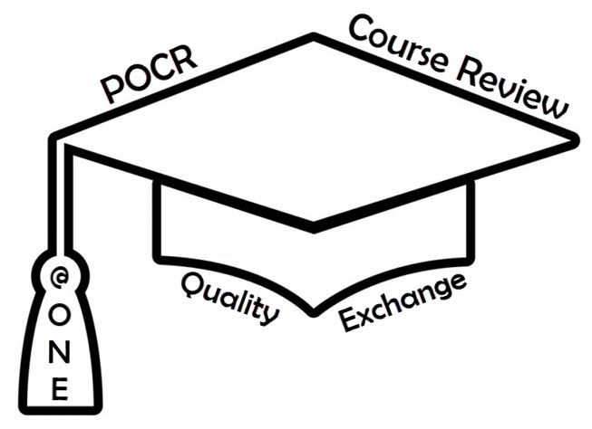
Keywords/Acronyms to consider:
- @ONE
- CVC-OEI
- LTIs
- POCR
- Course Exchange
- Ecosystem
- Innovation
- Student Services
- Student Success

Audio Feedback! Instructor Interactions that Motivate Students
Don Carlisle, Cabrillo College
Technical Setup  ·  · | Tips / Best Practices  ·  · | Feedback to student  ·  · | Student Perspective  ·  ·
11- 11:45 AM Canvas Combo Session 2

ConferZoom for Dynamic Student Conferences
Bri Kuhn, Cuyamaca College and DJ Hawkins, Riverside Community College District
To Do List:
- Sign up for your ConferZoom account if you don’t already have one.
- What is your personal meeting ID?
- How will you use ConferZoom in your course?
- ConferZoom tools/features you want to try:
- Tips to remember:

12 Noon Lunch Break - Canvas Trivia with Kahoot!
(download the mobile app to your phone) https://kahoot.com/mobile-app/

Quick Fixes using Tools to Create Accessible Content
Alice Dieli and Leslie Reeves, American River College
Use the space below to organize your notes.
 | Canvas Accessibility Checker | Grackle  for Google | Adobe Acrobat DC | Ally  in Canvas
How to Launch
Headers
Alt Text
Color Contrast
Student Options
Free or Cost?

Group Discussions for Increasing Interaction, Engagement, and Equity
Maritez Apigo, Contra Costa College
● Benefits:
● Tips:
● Best practices:
● Where I might use groups in my class:

1:00 - 1:45 PM Canvas Combo Session 2

Data at Your Fingertips: Supporting the Success of all Learners
Kim Vincent-Layton, Armeda Reitzel, and Becky Williams, Humboldt State University
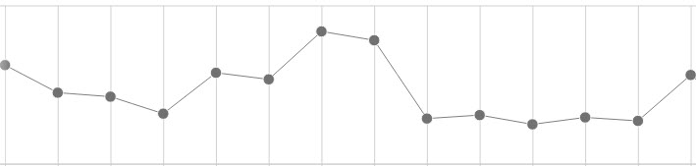
● How does Analytics (Beta) support student success?
● How does Analytics (Beta) support the instructor?
● Does my school have Analytics (Beta)?
● If not, who could you ask to get it implemented?

Using Flashcards for Self-Assessment
Ed Beyer, Antelope Valley College
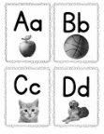
Benefits for Teachers and Students
● How might you use this practice in your course?
● List of resources:
● What do you need?
● Next steps?

2:00 - 2:45 PM Share Showcase Session 2

Embedding Quizzes in Video
Monique Kelley and JoEllen Green, Fresno City College
Follow along with this presentation
Short answer Quiz questions:
- What are the benefits of having quizzes in videos?
- How does this practice improve student engagement?
- Tools we already have?
- Budgetary considerations?

Design 2 Align Camp: A Model for Redesigning Courses in Community
Anna Stirling and Micah Orloff, Mt. San Jacinto College
Use the area below to write or draw your ideas.
Benefits | Challenges | Players
Faculty Reflections | Funding Options | More…?

3-3:45 PM Share Showcase Session 2

Taking the Pain Out of “Group Work”
Pat James, @ONE, and Aloha Sargent, Cabrillo College

• Tools • Collaboration Strategies • Groups • Participation • Feedback •

Stump the Panda
Erin Keefe, Panda (Instructure employee in disguise)
What did you learn from the Panda?

Bringing the CVC-OEI Online Ecosystem to Life through the MiraCosta College Student Support Hub
Bonnie Peters, CVC-OEI, Jim Julius and Karen Turpin, MiraCosta College
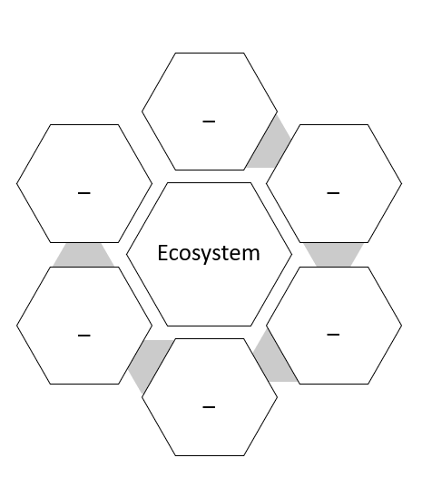
Brainstorm ideas for your own school/students - what would your ecosystem look like?

